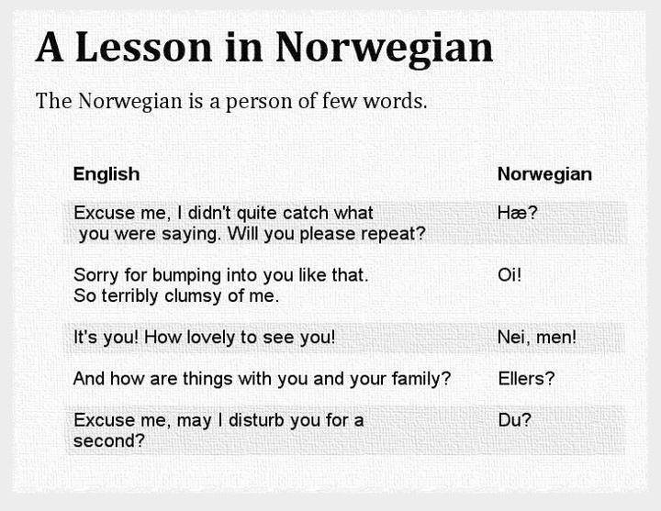
https://twitter.com/andasj/status/534437244745306112
7 Fascinating Facts about Norwegian language
Norwegian (Norsk) comes from the Germanic language group of the Indo-European family of languages. It is spoken by about 4.5 million Norwegians.
- Norwegian among other Scandinavian languages
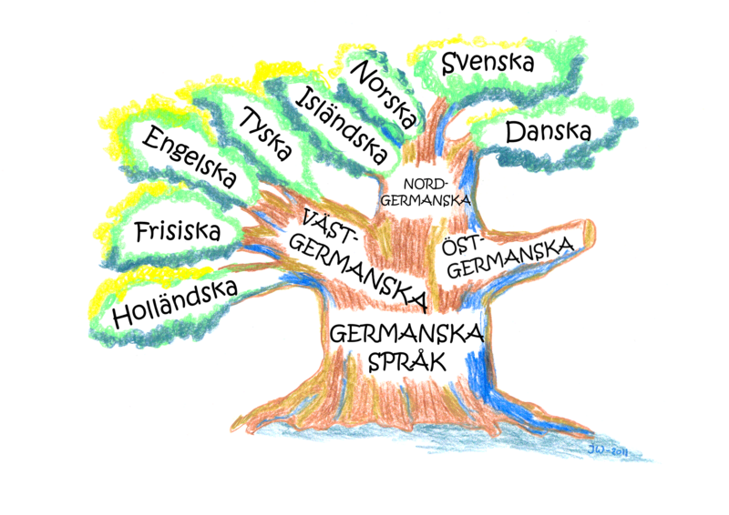
https://www.pinterest.com/straytravel/scandinavian-languages/
Historically Norwegian is mostly close to the Icelandic and Faroese languages which belong together to the North Germanic languages. Thanks to the significant influence of Danish and Swedish, Norwegian language is close to these languages as well. Due to modern classification Norwegian, Swedish and Danish form a group of continental Scandinavian languages unlike Island Scandinavian languages such as Icelandic and Faroese.
- “Cold” Language Birth circumstances
The development of writing came to Norway together with Christianity rather late, namely, in 11th century when Norwegians borrowed the Latin script. However, in 14th century the plague swept Norway which had led to almost complete decline of the kingdom (some historians state the loss of about 2/3 of population) after which Norway fell under the authority of Denmark. This situation continued more than 400 years, until 1814, when Norway was forced to enter the union with another country – Sweden.
- Riksmål and landsmål
For obtaining partial independence Norway has inherited quite chaotic language situation with capital-dominated Norwegian language riksmål (“State language”), on the one side, and landsmål (literally “rural language”) – a new literary language based on the West Norwegian dialect, one among many other Norwegian dialects, on the other side.
- Bokmål and Nynorsk as official forms of Norwegian
According to the law in 1885, in the schools children could choose which language to write in but they had to be able to read in both. The statesmen worried about the prospect of low literacy of the nation. So, Stortinget (the Parliament of Norway) carried out the unification reform of two orthographic versions of Norwegian language. Landsmål was renamed to “Nynorsk” (“New Norwegian”) and riksmål to “Bokmål” (“Book language”). By the end of the 20th century as a result of a number of government initiatives Bokmål and Nynorsk became more familiar to each other but haven’t lost their identity retaining its original features.
At present both forms are recognized as official. Bokmål is the first official language for 88% of population while Nynorsk is native to 12% (about a half of million people), most of whom live in the west of Norway and in Oslo.
- The alphabet
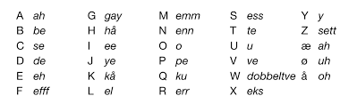
http://www.google.com.ua/url?sa=i&rct=j&q=&esrc=s&source=images&cd=&ved=0ahUKEwifiJWT7KfPAhXEjywKHWXEAQkQjxwIAw&url=http%3A%2F%2Fwww.keyword-suggestions.com%2Fbm9yd2VnaWFuIGFscGhhYmV0%2F&psig=AFQjCNGdL-BRzjg5EcqF3f1GP2V7dBnCTw&ust=1474800924201931&cad=rjt
Both Bokmål and Nynorsk use one alphabet modified on the base of Latin which includes 29 letters. There are 5 vowels, 3 diphthongs and 21 consonants in Norwegian.
- The Phonetics
The difference between Bokmål and Nynorsk concerns the phonetic composition of words and grammatical forms. A meaning of words usually is the same. In syntax differences between Bokmål and Nynorsk are negligible. Like all Scandinavian languages, in Norwegian all stressed syllables are long: rak [ra: k]. Vowels refer to long [u:] or short [u].
- Norwegian grammar
Norwegian grammar is rather complicated. The noun refers to one of three grammatical families – masculine, feminine or neuter. Words are used with masculine or feminine articles but actually only a dozen of words is used with feminine articles.
Added suffix denotes time or inclination. This is how verbs are conjugated. For example, a common suffix -er (-r) is added to regular verbs in the present tense. ‘Reise’ means “to travel” but ‘reiser’ means “I; you; he/she/it; we; they travel (-s)”.
Nevertheless the Norwegian has two official forms they both represent the same culture and nationality, namely, Norwegian.

